Soraphen A: a broad-spectrum antiviral natural product
with potent anti-hepatitis C virus activity

George Koutsoudakis, Inés Romero-Brey, Carola Berger, Gemma Pérez-Vilaró, Paula Monteiro Perin, Florian Wolfgang Rudolf Vondran, Markus Kalesse, Kirsten Harmrolfs, Rolf Müller, Javier P. Martinez, Thomas Pietschmann, Ralf Bartenschlager, Mark Bönstrup, Andreas Meyerhans, Juana Díez
Supplementary Material
Table of Contents

Supplementary Materials and Methods 2
Ethics statement 2
Cell culture 3
Primary human hepatocytes (PHHs) isolation, culture and infection 3
Plasmids 4
In vitro transcription and electroporation of HCV RNAs, generation of HCVcc stocks, luciferase assays, RT-qPCR and determination of virus titers in cell culture supernatants. 6
Generation of HCVcc stocks and determination of virus titers in cell culture supernatants. 7
Quantitative RT-PCR 7
Luciferase assays and cell cytotoxicity (viability) assays 8
Preparation of HCV pseudoparticles 9
Subgenomic replicon assay 9
HCV translation assay 10
Fatty acids rescue assay 10
Indirect immunofluorescence and confocal imaging 11
HCV inhibition in Stable Replicon Cell Lines 11
Supplementary Figure 1 13
Supplementary Figure 2 14
Supplementary Figure 3 15
References 16

Supplementary Materials and Methods

Ethics statement

The Investigation and Ethics Committee of the Centre for Experimental and Clinical Infection Research, Hannover, Germany approved our protocol, including the use of human samples, which conformed to the ethical guidelines of the 1975 Declaration of Helsinki. Written informed consent was obtained from all the patients included in this study.

Cell culture

Huh7/Scr cells, Huh7.5.1 Cl.2 cells (kindly provided by F. Chisari, The Scripps Research Institute, La Jolla, CA), Huh7-Lunet [1], Huh7-Lunet/T7 [2], Huh7.5 [3] and 293T cells (HEK293T cells, American Type Culture Collection, Manassas, VA, CRL-1573) were maintained in Dulbecco's Modified Eagle Medium (DMEM) (Invitrogen, Carlsbad, CA) supplemented with 10% fetal bovine serum, 1% nonessential amino acids, 100 units/ml penicillin and 100 units/ml streptomycin (DMEM complete). Cells were grown in an incubator with 5% CO₂ at 37ºC.

Primary human hepatocytes (PHHs) isolation, culture and infection

PHHs isolation was performed using a modified 2-step collagenase perfusion technique as previously reported [4]. In brief, liver specimens were obtained after partial hepatectomy, immediately cannulated under sterile conditions and flushed once with 500 ml pre-warmed (37ºC) washing buffer containing 2.5 mM EGTA. This was followed by perfusion with 100 ml of a pre-warmed (37ºC) digestion buffer containing 0.05% collagenase (Roche P, Mannheim, Germany) allowing for recirculation of the perfusate. Upon sufficient digestion, the tissue was mechanically disrupted and the emerging cell suspension poured through a gauze-lined funnel followed by centrifugation (50 x g, 5 min., 4ºC). The resulting cell pellet was washed twice using ice-cold PBS (50 x g, 5 min., 4ºC) and resuspended in William´s medium E (all Biochrom AG, Berlin, Germany) supplemented with 1 µM insulin, 1 µM dexamethason/fortecortin, 100 U/ml penicillin, 100 µg/ml streptomycin, 1 mM sodium pyruvate, 15 mM HEPES buffer, 4 mM L-glutamine and 5 % FCS. Cell number and viability were determined by the Trypan blue exclusion test. Hepatocytes were cultured using collagen pre-coated 6-well plates. Cells were seeded at a concentration of 1.5x10⁶ viable cells per well. Sixteen to eighteen hours after plating, culture medium was changed to remove dead and non-adherent cells. For Jc1 infections, PHHs were pre-incubated with SorA (10 µM) or VX-950 (1 µM) for 1 hour. Then, cells were infected with Jc1 virus (at an MOI of 0.2 TCID₅₀/cell) in the presence of SorA (10 μΜ) or Telaprevir (1 µM) for 6 hours. Finally, cells were washed twice with PBS and supplemented with fresh medium containing DMSO (0.1%). Cell culture supernatants were collected 24 and 48 h post-infection and the presence of HCV particles was measured by TCID₅₀ as described below. Cell viability in PHHs was measured by a MTT Cell Growth Assay Kit (Merck KGaA, Darmstadt, Germany), according to manufacturer’s instruction.

Plasmids

The plasmids pFK-Jc1 [5], pFK-Luc-Jc1 [6] and pFL-J6/JFH1/JC1p7Rluc2a (GNN) [7] have been previously described. The subgenomic replicon plasmid pSGR-JFH1 carries a bicistronic construct where a Firefly luciferase gene is expressed via the HCV IRES and an EMCV IRES drives expression of JFH1 non-structural proteins (NS3 to NS5B) [8]. pTN7-Stopp is a HIV plasmid that carries the Renilla luciferase reporter gene instead of the nef gene and lacks a functional env gene, thus set to produce only a single-round of infection [9]. The plasmid-encoding strain HC-J6CH E1E2 glycoproteins, named pcDNA3.1-ΔcE1E2-J6CH, has been described elsewhere [10].

Compounds

In this study we used SorA and SorA analogues. The compounds have been obtained by fermentation [11], or total synthesis [12]. The isolation of compounds NS462, NS464, NS476 and NS478 will be described elsewhere. The ACC inhibitor 5-(Tetradecyloxy)-2-furoic acid (TOFA) was purchased from Sigma-Aldrich (St. Louis, MO). The HCV NS3-4A serine protease inhibitor VX-950 (Telaprevir) and the NS5A inhibitor BMS-790052 (Daclatasvir, abbrev. DCV) were purchased from Selleck Chemicals (Houston, TX). Puromycin dihydrochloride and the fatty acids palmitic, oleic, myristic, lauric, the sphingolipid sphingomyelin, the ceramidase inhibitor ceranib-2, the phospholipid phosphatidylserine and the aromatic acid anthranilic acid were purchased from Sigma-Aldrich (St. Louis, MO). The 2'-modified nucleoside analog (2'-C-methyladenosine abbreviated 2'-C-Met) was kindly provided by Dr. Pablo Gastaminza (Spanish National Biotechnology Center, Madrid, Spain).

For compounds stock preparation, SorA, SorA analogues, TOFA, VX-950, DCV, ceranib-2 and anthranilic acid were diluted in DMSO at a final concentration of 10 mM. Palmitic acid, oleic acid, myristic acid, lauric acid and sphingomyelin were diluted in ethanol at final concentration of 50 mM. Phosphatidylserine was diluted in chloroform at a final concentration of 50 mM. Puromycin dihydrochloride was diluted in water at a final concentration of 50 mM.

In vitro transcription and electroporation of HCV RNAs, generation of HCVcc stocks, luciferase assays, RT-qPCR and determination of virus titers in cell culture supernatants.

pFK- plasmids carrying Jc1 constructs were linearized with the MluI enzyme while the pFL-J6/JFH1/JC1p7Rluc2a (GNN) and pSGR-JFH1 plasmids were linearized with the XbaI enzyme. Linearized plasmid DNA was purified with the QIAquick PCR purification kit (Qiagen, Düsseldorf, Germany). Purified DNA was subjected to an in vitro transcription reaction with the MEGAscript® T7 kit (Applied Biosystems, Foster city, CA) according to the manufacturer's protocol. RNA from the in vitro transcription reaction was purified with the Nucleospin® RNA II kit (Macherey-Nagel, Düren, Germany), RNA integrity was verified by formaldehyde agarose gel electrophoresis and the concentration was determined by measurement of the optical density at 260 nm. For RNA electroporations, single cell suspensions of Huh7.5.1 Cl.2 cells were prepared by trypsinization of cell monolayers. Cells were washed with phosphate-buffered saline (PBS), counted, and resuspended at 1.5×10⁷ cells per ml in Cytomix [13] containing 2mM ATP and 5mM glutathione. Ten µg of in vitro transcribed RNA was mixed with 400 µl of the cell suspension. Cells were then electroporated, immediately transferred to 10 ml of culture medium and seeded in a 10-cm dish. Electroporation conditions were 975 µF and 270 V by using a Gene Pulser Xcell™ system (Bio-Rad, Munich, Germany) and a cuvette with a gap width of 0.4 cm (Bio-Rad).

Generation of HCVcc stocks and determination of virus titers in cell culture supernatants.

For the generation of HCVcc stocks, supernatants of the electroporated cells were harvested 72 h post electroporation, cleared by passing them through 45-µm-pore-size filters and stored at -80ºC.
For the determination of viral titers Huh7/Scr cells were seeded at a concentration of 1.2×10⁴ cells per well in a 96-well plate in a total volume of 200 µl. Twenty-four hours later, serial dilutions of virus containing supernatant were added (6 wells per dilution.) Three days later, cells were washed with PBS and fixed for 20 min with ice-cold methanol at −20°C. After three washes with PBS, NS5A was detected with a 1:2000 dilution of the α-NS5A antibody 9E10 (kindly provided by C. Rice, The Rockefeller University, NY) in PBS supplemented with 5% BSA for 1 h at room temperature. Cells were washed again three times with PBS and bound primary antibodies were detected by incubation in PBS-5% BSA with goat α-mouse IgG-peroxidise conjugated antibody (Sigma-Aldrich, St. Louis, MO) at 1:400 dilution. After 1 h incubation at room temperature, cells were washed three times with PBS; the Vector NovaRED substrate kit (Linaris Biologische Produkte GmbH, Wertheim, Germany) was used for detection of peroxidase. Virus titers [50% tissue culture infective dose per ml (TCID₅₀/ml)] were calculated based on the method described by Spearman and Kärber.

Quantitative RT-PCR

RNA from Jc1 infected Huh7/Scr cells was extracted using the Nucleo Spin RNAII kit (Macherey-Nagel, Düren, Germany) following the manufacturer's protocol. RNA concentration was determined by measurement of the optical density at 260 nm. Twenty ng of the total RNA sample was used for quantitative PCR analysis using a 7500 Real-Time PCR sequence detector system (Applied Biosystems, Waltham, MA). HCV-specific RT-qPCRs were conducted in duplicate for each sample with the qScript™ XLT One-Step RT-qPCR ToughMix®, ROX™ (Quanta Biosciences, Gaithersburg, MD) using the following 5′ NTR-specific probe: S-292, 5'-6-carboxyfluorescein- CCTGATAGGGTGCTTGCGAGTGCC -tetrachloro-6-carboxyfluorescein-3'; and primers: S-271, 5'- GCGAAAGGCCTTGTGGTACT-3'; and A-337, 5'- CACGGTCTACGAGACCTCCC -3' (Biomers, Ulm, Germany). Reactions were performed in three stages by using the following conditions: stage 1, 15 min at 50°C (reverse transcription); stage 2, 1 min at 95°C (heat inactivation of reverse transcriptase and activation of Taq polymerase); and stage 3, 40 cycles of 10 s at 95°C and 1 min 60°C (amplification). The amount of HCV RNA was calculated by comparison to serially diluted in vitro transcripts.

Luciferase assays and cell cytotoxicity (viability) assays

For standard infection assays Huh7/Scr cells were seeded at a density of 1.2 x 10⁴ cells/well in 96-well plates. One day later cells were pre-incubated for 1h at 37ºC with the pertinent compounds and then inoculated with the virus and the compounds for 4h at 37ºC. HCVpp were left for 6h. Finally, virus-containing media was replaced by a fresh media-compounds mix. Firefly and Renilla luciferase activities were assayed 72h post infection with the Dual-Glo® Luciferase Assay System while cytotoxicity (viability) assays were carried out with the CytoTox-Glo™ Cytotoxicity Assay (both purchased from Promega Corporation, Madison, WI), according to manufacturer’s instructions, using a plate luminometer FLUOstar OPTIMA (BMG LABTECH, Ortenberg, Germany). Mean relative light units (RLU) were plotted as percentage relative to control infections (solvent without compounds) for both infectivity and cell viability. Infections were carried out in duplicates and measured in duplicates (mean ± SEM; n=4). Half maximal effective concentration (EC₅₀) and half maximal cytotoxic concentration 50 (CC₅₀) were estimated by non-linear regression of log inhibitor vs. normalized response and used to calculate the Selectivity Index (SI) value.

Preparation of HCV pseudoparticles

HIV-based pseudoparticles bearing HCV glycoproteins were generated by calcium phosphate cotransfection of 293T cells. Briefly, 3,6 x 10⁶ 293T cells were seeded in 10-cm dishes one day before transfection with equal amounts of pTN7-Stopp plasmid and pcDNA3.1-ΔcE1E2-J6CH. A total amount of 20 µg of DNA was mixed with a 2M CaCl₂ solution and then 2X Hepes Buffered Saline (HBS) was added dropwise to form a precipitate which was added to the cells. The medium was replaced the following day and supernatants containing the pseudo-particles were harvested 48 h later, cleared by passage through 0.45-μm-pore-size filters, and used for luciferase infection assays.

Subgenomic replicon assay

Huh7/Scr cells were seeded at a density of 5 x 10⁴ cells/well in 24-well plates. The following day, cells were pre-incubated with the pertinent compounds for 1h prior to subgenomic replicon RNA transfection. Transfections were done using the Lipofectamine® 2000 solution (Life Technologies, Carlsbad, CA) according to manufacturer’s instructions, in the presence of SorA or control compounds. 6h post transfection, transfection medium was replaced with fresh medium and fresh compounds were added. Firefly luciferase activity was measured 48h later as described above.

HCV translation assay

Huh7/Scr cells cells were pre-incubated with the pertinent compounds (1 μΜ SorA, or 1 μΜ VX-950 or 5 μΜ TOFA) for 18h prior to SGR-JFH1 RNA electroporation as described in the Supplementary Material section. Electroporated cells were transferred into 10 ml DMEM complete medium in the presence of the pertinent compounds. Cells were seeded at a density of 1 x 10⁵ cells/well in 24-well plates. 4h later, cells were trypsinized and split into 2 vials. For every well 1 vial served for Firefly luciferase asssays and the other vial for total RNA extraction and RT-qPCR as described above. For the puromycin treatment, Huh7.5 cells were electroporated with J6/JFH1/JC1p7Rluc2a (GNN) RNA, which is a non-replicating HCVcc RNA that expresses Renilla luciferase protein. After electroporation cells were treated for 1h with 100 μg/mL puromycin and Renilla luciferase activity was measured as described above.Final data are given as mean RLUs from duplicate wells measured in duplicates and normalized to the HCV RNA.

Fatty acids rescue assay

For fatty acids rescue assays Huh7/Scr cells were seeded at a density of 1.2 x 10⁴ cells/well in 96-well plates. One day later cells were pre-incubated for 1h at 37ºC with SorA at a final concentration of 10 nM. Then cells were inoculated with the Luc-Jc1 virus in the presence of SorA (10 nM) and either palmitic acid (10 or 50 μM), or oleic acid (10 or 50 μM), or myristic acid (10 or 50 μM), or lauric acid (10 or 50 μM), or sphingomyelin (10 or 50 μM) and the ceramidase inhibitor ceranib-2 (1 μM), or phosphatidylserine (10 or 50 μM) and anthranilic acid (10 μM). Cells were incubated with viruses and compounds for 4h. Finally, virus-containing media was replaced by a fresh media-compounds mix. Firefly luciferase activities were assayed 72h post infection as described above.

Indirect immunofluorescence and confocal imaging

Immunofluorescence analyses were performed as previously described. Nuclei were labeled with 4′,6-diamidino-2-phenylindole (DAPI) (Invitrogen, Carlsbad, CA). Cells were washed with PBS and mounted in Mowiol (Sigma-Aldrich, St. Louis, MO). Images were acquired with a Leica TCS SP5 confocal microscope using a 63× 1.4-NA PL APO objective (Leica Microsystems GmbH, Wetzlar, Germany). For each condition 5 different non-overlapping fields were acquired.

HCV inhibition in Stable Replicon Cell Lines

To assess the inhibitory effect of SorA in stable replicon cell lines, the LucUbiNeo Con1-ET cells [14] or the LucUbiNeo JFH1 cells [15] were seeded into a 12-well plate at a density of 4 × 10⁴ cells/well. One day later, SorA was added at different concentrations. The NS5A inhibitor DCV was used a positive control. As mock control, DMSO was added according to the highest inhibitor concentration used in the assay. After 72 hours of treatment, cells were washed, lysed, and analyzed by luciferase activity assay as described above.

Electron microscopy analyses

This method was employed as previously described [16]. Briefly, Huh7/Lunet cells were electroporated with 5µg of in vitro transcripts using full-length virus Jc1. Subsequently, 3x 10⁴ cells were seeded in a 24-well plate with medium containing the indicated concentrations of DMSO, SorA or DCV. Cells were incubated for 96h with a medium change after 48h again adding the indicated inhibitor concentrations. Next, cells were fixed for indicrect immunofluorescence (IF) analysis (4% paraformaldehyde in PBS, 10'), electron microscopy (EM; 2.5% glutaraldehyde in 50 mM sodium cacodylate buffer[pH 7.2] containing 1M KCl, 0.1M MgCl2, 0.1M CaCl2 and 2% sucrose, 30’) or harvested for western blot (WB) analysis using 2x SDS sample buffer (400 mM Tris [pH 8.8], 10 mM EDTA, 0.2% bromophenolblue, 20% sucrose, 3% SDS, and 2% betamercaptoethanol).

Statistical analyses

The statistical comparison between two groups was made by an unpaired-t test. *p value < 0.05, **p value < 0.01 and ***p value < 0.001 were considered to indicate a significant difference.

Supplementary Figure 1

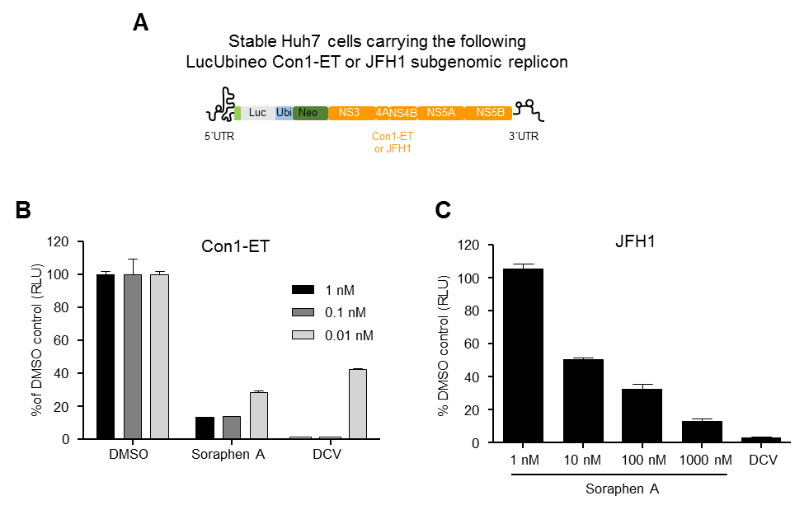
Supplementary Fig. 1: Soraphen A inhibits HCV replication in stable cell lines carrying the LucUbineo Con-ET or JFH1 subgenomic replicons. (A) Molecular structure of the LucUbineo replicons (B) Anti-HCV activity of SorA in stable Huh7 cells harbouring the LucUbineo Con1 replicon. The NS5A inhibitor Daclatasvir (DCV) was used as positive control at the indicated concentrations. (C) Anti-HCV activity of SorA in stable Huh7 cells harbouring the LucUbineo JFH1 replicon. The NS5A inhibitor Daclatasvir (DCV) was used as positive control at 100 nM. Data are expressed as mean values of four measurements of two biological replicates (±SEM).

Supplementary Figure 2

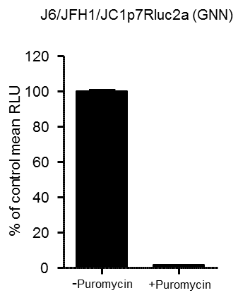
Supplementary Fig. 2: Effect of puromycin treatment in HCV RNA translation. Huh7.5 cells were electroporated with a non-replicating HCVcc RNA that expresses Renilla luciferase protein [J6/JFH1/JC1p7RLuc2A (GNN)]. After electroporation cells were treated for 1h with puromycin (100μg/mL) or mock treated and luciferase activity was measured. Data are expressed as mean values of four measurements of two biological replicates (±SEM).

Supplementary Figure 3

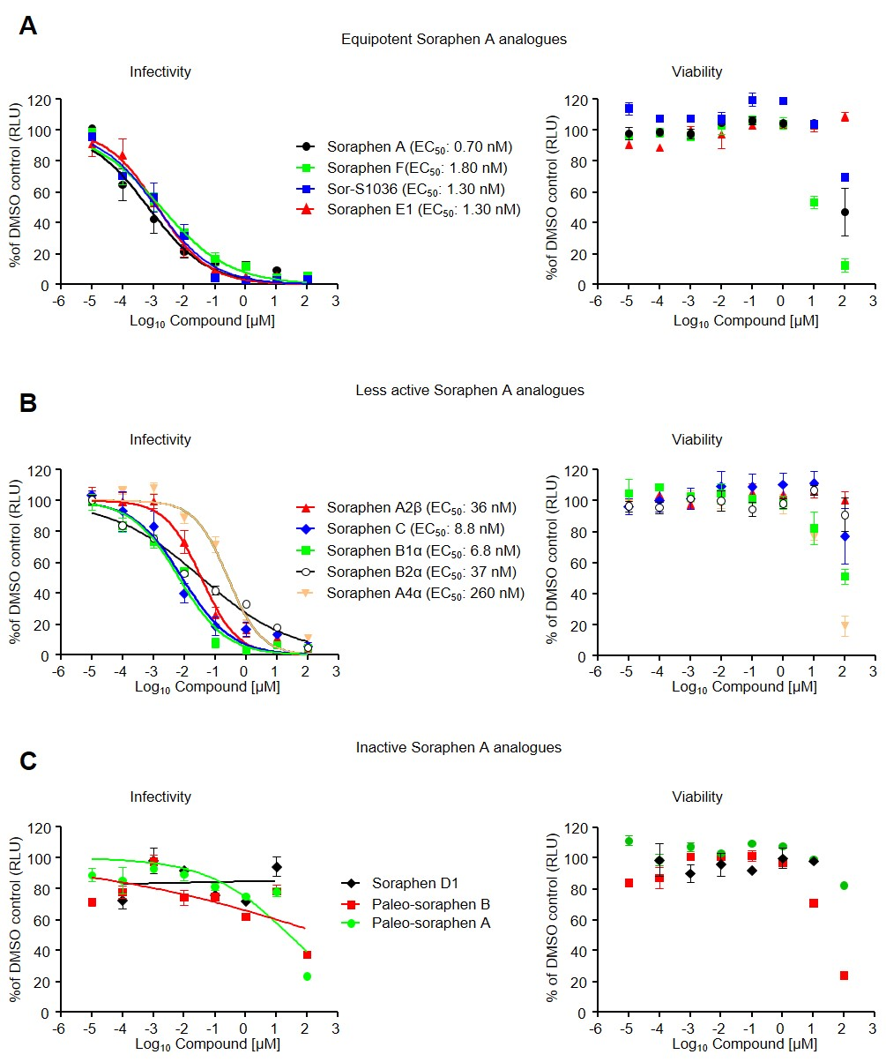
Supplementary Fig. 3: Soraphen A analogues inhibit HCV genotype 2a. Anti-HCV activity and viability on Huh7/Scr cells infected with Luc-Jc1 viruses and treated with increasing concentrations of SorA or the depicted SorA analogues. Results of SorA analogues are grouped according to SorA equipotency (A), less SorA potency (B) or inactive SorA analogues (C). All data were plotted as percentage relative to DMSO control for both infectivity and cell viability. Data as shown are the mean (±SEM) of three independent experiments.

References

[1] Friebe P, Boudet J, Simorre JP, Bartenschlager R. Kissing-loop interaction in the 3' end of the hepatitis C virus genome essential for RNA replication. Journal of virology 2005;79:380-392.
[2] Backes P, Quinkert D, Reiss S, Binder M, Zayas M, Rescher U, et al. Role of annexin A2 in the production of infectious hepatitis C virus particles. J Virol 2010;84:5775-5789.
[3] Blight KJ, McKeating JA, Rice CM. Highly permissive cell lines for subgenomic and genomic hepatitis C virus RNA replication. Journal of virology 2002;76:13001-13014.
[4] Kleine M, Riemer M, Krech T, DeTemple D, Jager MD, Lehner F, et al. Explanted diseased livers - a possible source of metabolic competent primary human hepatocytes. PloS one 2014;9:e101386.
[5] Pietschmann T, Kaul A, Koutsoudakis G, Shavinskaya A, Kallis S, Steinmann E, et al. Construction and characterization of infectious intragenotypic and intergenotypic hepatitis C virus chimeras. Proceedings of the National Academy of Sciences of the United States of America 2006;103:7408-7413.
[6] Wakita T, Pietschmann T, Kato T, Date T, Miyamoto M, Zhao Z, et al. Production of infectious hepatitis C virus in tissue culture from a cloned viral genome. Nat Med 2005;11:791-796.
[7] Scheller N, Mina LB, Galao RP, Chari A, Gimenez-Barcons M, Noueiry A, et al. Translation and replication of hepatitis C virus genomic RNA depends on ancient cellular proteins that control mRNA fates. Proceedings of the National Academy of Sciences of the United States of America 2009;106:13517-13522.
[8] Kato T, Date T, Miyamoto M, Furusaka A, Tokushige K, Mizokami M, et al. Efficient replication of the genotype 2a hepatitis C virus subgenomic replicon. Gastroenterology 2003;125:1808-1817.
[9] Neumann T, Hagmann I, Lohrengel S, Heil ML, Derdeyn CA, Krausslich HG, et al. T20-insensitive HIV-1 from naive patients exhibits high viral fitness in a novel dual-color competition assay on primary cells. Virology 2005;333:251-262.
[10] Koutsoudakis G, Dragun J, Perez-Del-Pulgar S, Coto-Llerena M, Mensa L, Crespo G, et al. Interplay between basic residues of hepatitis C virus glycoprotein E2 with viral receptors, neutralizing antibodies and lipoproteins. PloS one 2012;7:e52651.
[11] B. Böhlendorf. [PhD Thesis]: Technical University of Braunschweig; 1991.
[12] Lu HH, Raja A, Franke R, Landsberg D, Sasse F, Kalesse M. Synthesis and biological evaluation of paleo-soraphens. Angewandte Chemie 2013;52:13549-13552.
[13] van den Hoff MJ, Christoffels VM, Labruyere WT, Moorman AF, Lamers WH. Electrotransfection with "intracellular" buffer. Methods in molecular biology 1995;48:185-197.
[14] Frese M, Barth K, Kaul A, Lohmann V, Schwärzle V, Bartenschlager R. Hepatitis C virus RNA replication is resistant to tumour necrosis factor-α. Journal of General Virology 2003;84:1253-1259.
[15] Jo J, Aichele U, Kersting N, Klein R, Aichele P, Bisse E, et al. Analysis of CD8+ T-cell-mediated inhibition of hepatitis C virus replication using a novel immunological model. Gastroenterology 2009;136:1391-1401.
[16] Berger C, Romero-Brey I, Radujkovic D, Terreux R, Zayas M, Paul D, et al. Daclatasvir-Like Inhibitors of NS5A Block Early Biogenesis of Hepatitis C Virus-Induced Membranous Replication Factories, Independent of RNA Replication. Gastroenterology 2014.

